***Etude 02 – LoopyLoop***

**Part One:**

I started by grouping the components needed for the keyboard circuit. I am beginning to differentiate the resistors better between each other. I started a personalized legend not to forget the differences between resistors. I grouped the needed resistors into their own set and wrote a little note to differentiate each group. Once I brought all the required components together, I started to build up the circuit by following the steps carried in the Etude 02’s PDF. For this etude, I was more comfortable building the circuit; I could build it in a shorter amount of time.

A picture of the first step: grouping components.

A picture of my personal resistor legend.

A picture of the second step: connecting RGB LED to the breadboard.

A picture of the third step: adding buttons to the breadboard.

A picture of the fourth step: adding Piezo buzzer to the breadboard.

A picture of the fifth step: connecting mode button to the breadboard.

A picture of the sixth step: connecting missing wires to the breadboard and voltage pins on the Arduino.

The most complex part was to build the code. I spent days and hours working on this code. I had to watch recordings of past classes, tutorials and look at the Arduino API to find ways to write it. I asked for help a few times during my process. At the first trial, my code didn’t work. While checking my code and circuits, I found out that I was using the wrong buzzer; I put the passive buzzer instead of the Piezo buzzer. I also noticed I mistaken another component as the RGB LED. I changed it for the appropriate LED. After many trials and corrections, I was able to finish writing the whole code and make the circuit and all its modes work.

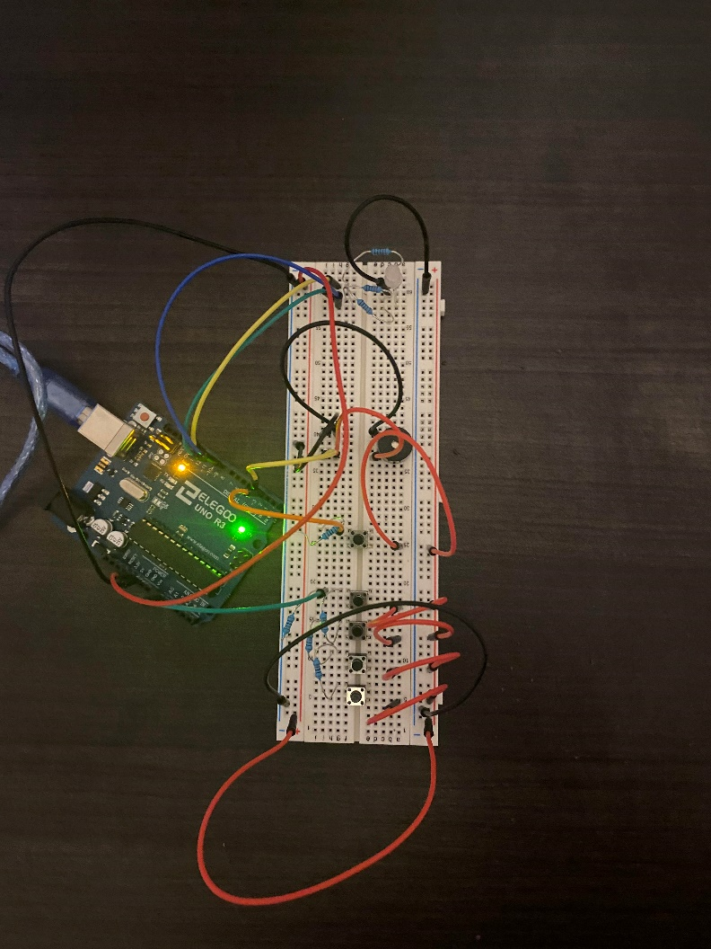

A picture of the working circuit with the right components.

A picture of the live mode.

A picture of the record mode.

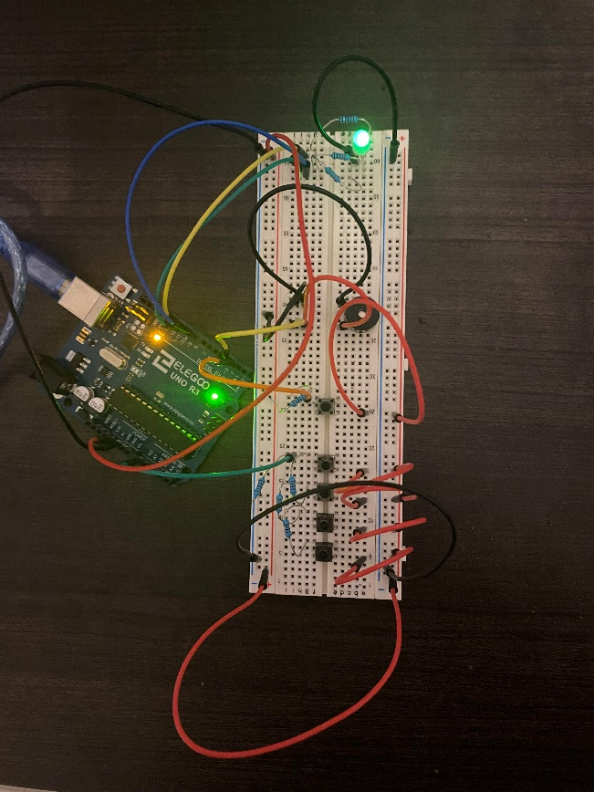

A picture of the play mode.

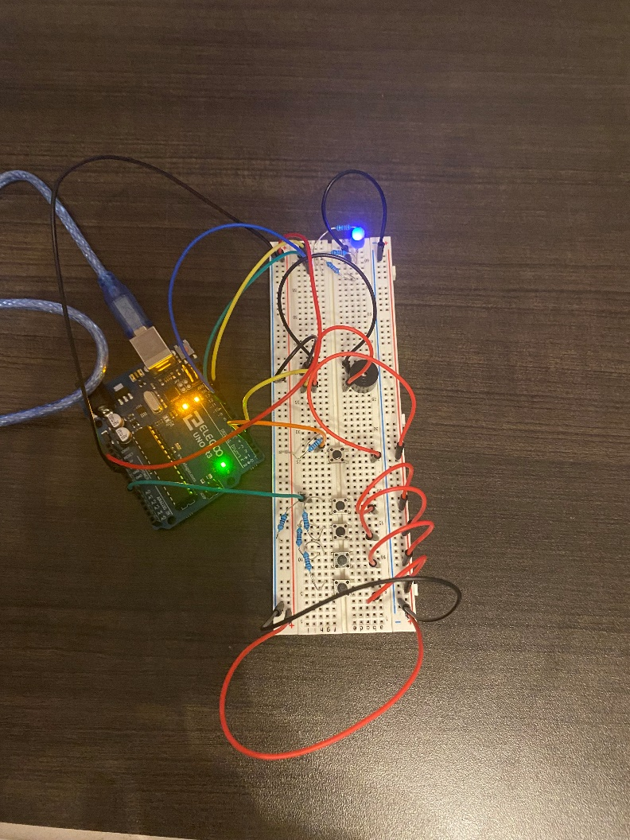

A picture of the looper mode

While the circuit was working, I noticed that the produced notes were different for each button; there was a slight variation in the sounds. The sounds themselves were high-pitched and buzzy. I also noticed that the LED divided the colours blue and red to create the purple colour. It was easy to make some confusion within the circuit. If I slightly moved some components (i.e., wires, resistors, etc.), it affected the circuit (i.e., colours of the LED changed, produced sounds without pressing buttons, etc.)